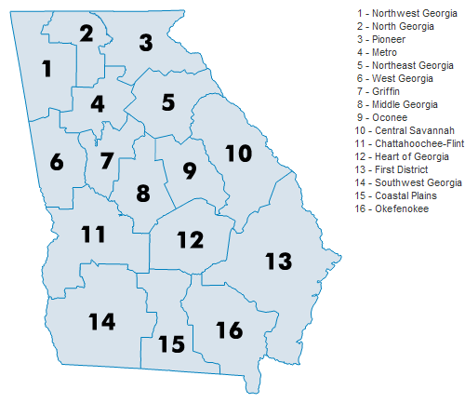  GATESOL’s Purpose  - To encourage professional development, participation and leadership within the state of Georgia.  - To provide opportunity for study and research.  - To work cooperatively toward the improvement of instruction in all programs which seek to provide students with an opportunity to acquire English language skills and proficiency.  - To promote an understanding of the cultures of non-native speakers of English. |  | 2017 - 2018 Pres. Kendra M. Castelow kendracastelowgatesol@gmail.com Past Pres.Cherrilynn Woods-Washington gatesolwashington@gmail.com 1st VP Lela Horne gatesol2018@gmail.com 2nd VP Greg Wickersham greg.wickersham@gmail.com Secretary Jennifer Pendergrass canvasfeedback@gmail.com Treasurer Christina Catinella gatesoltreasurer@gmail.com Join Our Facebook Group: GATESOLpeachgroup Like Us on Facebook: GATESOLpeach Follow Us on Twitter: @GATESOLpeach  P.O. Box 17933 Atlanta, GA 30316 USA www.gatesol.org |  | - Georgia Teachers of English to Speakers of Other Languages

Nearly $12,000 are given away every year!  Grants:  - John R. Stowe Cultural Immersion Grant  - Beverly Benson Travel Grant  - Lindy Lopez-Butner Memorial Grant  - Community Support Grant  - Project/Professional Development Grant I: PK-12  - Project/Professional Development Grant II: Adult or Higher Education  - SE TESOL Conference Travel Grant  - Georgia/Peru TESOL Travel Grant  Awards:  - Public Service Award  - Youth Public Service Award  - Professional Service Award  Visit www.gatesol.org and click on the Grants & Awards tab! |  | Do you want to be a part of a dynamic and influential group?  - First-timers become a member of GATESOL and TESOL International Association at a discounted price!  - Our fees are reasonable and made just for you!  1 year - $30.00 US  5 years - $120.00 US  1 year (full-time students) - $15.00 US  Members enjoy access to our GATESOL Newsletter and peer-reviewed journal, GATESOL In Action.  Visit www.gatesol.org and click on the Membership tab! |  | People are talking about all that GATESOL offers!  “GATESOL membership provides a sense of belonging that empowers educators to be catalysts of change in multilingual and multicultural societies.”  K.C. – GATESOL Member  Our Interest Sections:  - Adult Education  - Applied Linguistics  - Bilingual Education  - Elementary Education  - Higher Education  - Intensive English Program (IEP)  - Intercultural Communication  - Job Board  - Regional Liaisons  - Second Language Writing  - Sociopolitical Concerns  - Teacher Education  Visit www.gatesol.org and click on the Forums’ tab!

